**Topic 5 Assignment / Chapter 11**

**Windows Programming & CIS-2225**

|  |  |
| --- | --- |
| Author: | Christopher Sigouin |
| Date: | October 22, 2015 |
| Due Date: | October 26, 2015 |
| Assignment: | Topic 5 Chapter 11 |
|  |  |
|  |  |
| Mark: | __________ |

|  |  |
| --- | --- |
|  | CIS-2225 Windows Programming |

Topic 5

|  |  |
| --- | --- |
| To: | Gerald Caissy |
| From: | Christopher Sigouin |
| Date: | November 6, 2015 |
| Subject: | Chapter 11 / Exercise 9 – DLL usage |
|  |  |

This assignment was to build dynamic link libraries (DLL) based on the three classes advised in the following exercise:

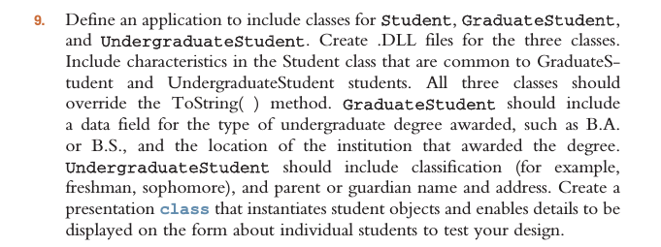

Each class was built as specified within the exercise description. The applications design interface was not specified, therefore, the details displayed for each class were hard coded into the applications “Student Handler” class that stands between the DLL references and the “Student Display Form”. The handler completes the instantiation of each class to display inside the display area on the form. Each instantiation also utilizes its own overridden “ToString” method.